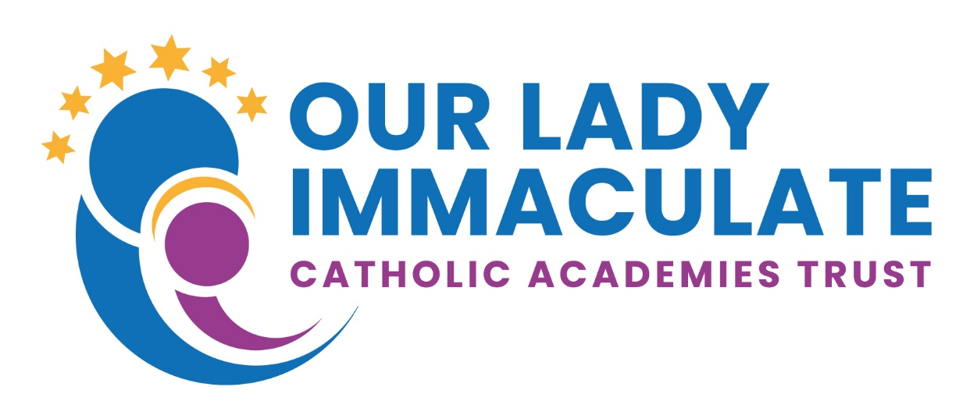

Charging and Remission Policy

Policy reviewed and adopted by Trust Board | Delegated to SEL.  Approved September 2023
Review frequency | Annually
Date of next review | September 2024
Responsible Officer | Sue Robinson

Introduction
Our Lady Immaculate Catholic Academies Trust is committed to the general principle of free education and recognise the valuable contribution that a wide range of activities, including school visits and residential experiences, can make towards all aspects of student’s education. It also believes that all our students should have an equal opportunity to benefit from academy activities and visits (curricular and extracurricular) independent of their parent’s financial means.

The Trust recognises its responsibility to ensure that the offer of activities and educational visits does not place an unnecessary burden on family finances. It is acknowledged that offering opportunities on a ‘first pay, first served’ basis discriminates against pupils from families on lower incomes and we will endeavour to avoid that method of selection.

1996 Education Act requires all schools to have a policy on charging and remissions for school activities, which will be kept under regular review.

The policy identifies activities for which:

- Voluntary contributions may be requested.
- Charges will be made.
- Charges will not be made.
- Charges may be waived.

Voluntary Contributions
Separately from the matter of charging, schools may always seek voluntary contributions in order to offer a wide variety of experiences to pupils. All requests for voluntary contributions will emphasise their voluntary nature and the fact that pupils of parents who do not make such contributions will be treated no differently from those who have.

The law states:
If the activity cannot be funded without voluntary contributions the LAC or Headteacher will make this clear to parents from the outset.

No child will be excluded from an activity because his or her parents are unable or unwilling to pay.

If insufficient contribution are received, the trip or activity may have to be cancelled.

If a parent is unwilling or unable to pay their child will still be given an equal chance to go on the visit.

Charges Will Be Made
The Trust reserves the right to make a charge for the following activities which may from time to time be organised by the school:

Activities outside school hours – the school will endeavour to provide a range of such activities from time to time. These will sometimes include day and residential experiences, and are known generally as ‘optional extras’. Charges may be made for these activities EXCEPT where they are provided to fulfil any requirements specified in the syllabus of a prescribed public examination or are required in order to fulfil statutory duties relating to the National Curriculum or to religious education in which case they are not regarded as optional extras as such and charges cannot be made. (Board and lodging charges may still however be made for any residential activities subject to the remission arrangements described below (time spent on travel counts in this calculation if the travel itself occurs during school hours).

Residential activities held during schools hours – charges may be made for the board and lodging element of those residential activities during school hours. Parents will be notified in advance of any such activities which the school proposes to organise and the estimated cost. Parental consent will be obtained for their children’s participation in any such activities for which a charge may be made. However pupils whose parents are in receipt of certain benefits (see remissions policy) may not be charged for board and lodging costs.

Music Tuition – music tuition for individuals or groups of up to 4 pupils.

Home to school student transport – costs incurred by the school in providing home to school transport for students.

Parents will be notified in advance of any ‘optional extras’ which the school proposes to organise and the estimated cost. Parental consent will be obtained if their children are to participate in any activities for which a charge may be made.

Any charge for a particular activity will be dependent upon the type of activity and its costs and the number of participants. This charge will not exceed the actual cost of providing the activity, divided equally by the number of pupils willing to participate. The cost of other pupils participating in the visit will not be included in the charge. The charge may however include an appropriate fee for such things as:

- The pupil’s travel costs.
- The pupil’s board and lodging costs.
- Materials, books, instruments and other equipment.
- Non-teaching staff costs.
- Entrance fees to museums, castles, theatres etc.
- Insurance costs.
- The expenses only of participating teachers engaged on a separate contract for services to provide the ‘optional extra’.

Charges Will Not Be Made
Charges will not be made for the following:

- An admission application.
- Education provided during school hours (including the supply of any materials, books, instruments or other equipment).
- Educational provided outside school hours if it is part of the National Curriculum or part of a syllabus for a prescribed public examination that the pupil is being prepared for at the school, or part of the school’s basic curriculum for religious education.
- Tuition for pupils learning to play musical instruments (or singing) it the tuition is required as part of the National Curriculum, or part of a syllabus for a prescribed public examination that the pupil is being prepared for the school, or part of religious education.
- Entry for a prescribed public examination, if the pupil has been prepared for it at the school.
- Examination re-sit(s) if the pupil is being prepared for the re-sit(s) at the school. However, if a pupil fails, without good reason, to meet any examination requirement for a syllabus a charge will be made.
- Education provided on any trip that takes place during school hours.
- Education provided on any trip that takes place outside school hours, is part of the National Curriculum, or part of a syllabus for a prescribed public examination that the pupil is being prepared for at the school, or part of the school’s basic curriculum or religious education.
- Supply teachers to cover for those teachers who are absent from school accompanying pupils on a residential trip.
- Transport provided in connection with an educational trip.

Remissions
In order to remove financial barriers, form disadvantaged pupils, the Trust has agreed that some activities and visits where charges can legally be made will be offered at no charge or a reduced charge to parents in particular circumstances. The remissions policy sets out the circumstances in which such charges will be waived.

Charges may be remitted in whole or part at the discretion of the Head for families in receipt of income support or family credit, or whose income is assessed at the level equivalent to qualify for these benefits. In these circumstances, application should be made to the Head at the school, and will be treated in confidence.

Additional categories of parents may claim help with some costs in the following circumstances:

- Specific individual circumstances that have caused temporary hardship.
- Recently moved into hardship but not yet receiving the benefits mentioned above.
- Made a specific request to Head Teacher for any other justifiable reason. The remission is at the Head Teacher’s discretion in these circumstances based on any evidence provided.

